***Robotic Process Automation***

***- A path to the cognitive enterprise***

The Automation of knowledge work will be this decade’s engine of growth.

By freeing up human labor to provide additional strategic work, RPA simply creates more value with less investment.

***What is this RPA (Robotic Process Automation)?***

In this highly competitive world, work areas are burdened with time-consuming and repetitive processes. Clients want to improve delivery, reduce costs and ensure consistent quality in their work. Robotic process automation or RPA has now become a trend for all types of businesses. RPA takes the robot out of the human. Processes are built by showing the robots what to do step by step rather than coding or scripting them, in exactly the same way as a human would use the end user systems. It can do repetitive stuff more quickly, accurately, and tirelessly than humans, freeing them to do other tasks requiring human strengths such as emotional intelligence, reasoning, judgment, and interaction with the customer.

***Why Robotic Process Automation brings something new and how is this different from other Automations?***

RPA describes not just a new flavor of technology but a new approach to addressing office-centric data handling and processing tasks – those that previously required manual re-keying, spreadsheets, hard-copy documents and swivel chair workers to perform.

There are several fundamental characteristics of this kind of technology enabled solution that differ from Business Process Management (BPM) tooling and other traditional IT dependent solutions:

* The RPA doesn’t fundamentally change the operation of the process. Instead of a human tapping the keys and building spreadsheets, a computer software application mimics the same tasks in a similar way. The same process stages will generally occur.
* Training of robots is generally performed using code-free software, so its quick to do and easy to adapt.
* IT challenges like implementing complex APIs are removed by re-keying or robotically extracting/uploading data to legacy system.
* Rather than being ‘a technology platform’ purchased and operated by IT- requiring a big up-front investment and lot of risks, ‘Robots’ are the resources that can be outsourced in the same way as people, individually selected by departmental managers and billed monthly with all the contractual flexibility that represents.

***How does RPA work?***

It’s a way of Artificial Intelligent or rather virtual workers performing the activities as exactly as human does.

Let’s take a business process example, when a new joiner comes in the team how he/she gets trained to do a task, the same way these virtual workers also need to be trained step by step.

Once the Robots are trained then they are the lifetime permanent workers, no attrition unlike human workers.

Robotic Process Automation can be used in many fields, below image would give us a brief idea of use cases for RPA.

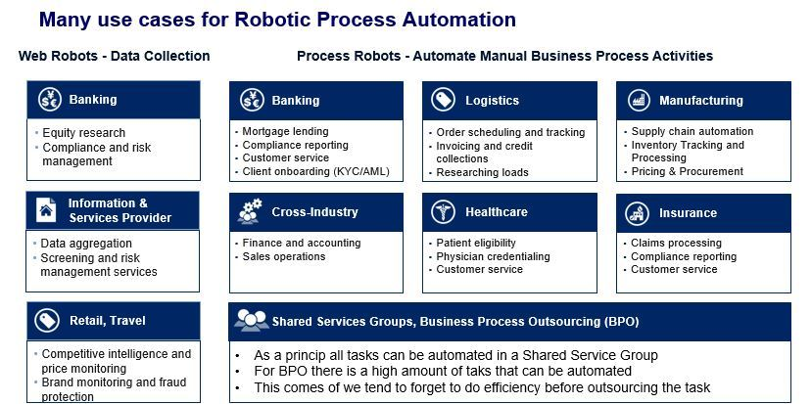

***RPA Tools!***

The most popular RPA tools are:

* *Blue Prism:*

The term Robotic Process Automation was invented by Blue Prism, that itself proves they are the pioneers in Robotic Process Automation software development. Blue Prism has been recognized by the American IT research and advisory company Gartner, Inc. They already have more than 100 customers around the world and partnered with biggest giants like NHS, Accenture, Hexaware, Hewlett Packard Enterprise, Capgemini, IBM etc*.*

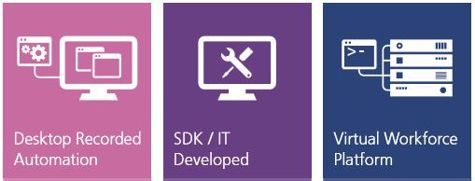

*Blue Prism*

* *Automation Anywhere:*

Automation Anywhere is another top RPA vendors providing powerful and user-friendly robotic process automation tools to automate tasks of any complexity. They are partnered with companies like EMC2, KPMG, Deloitte, Accenture, Genpact, Infosys etc.

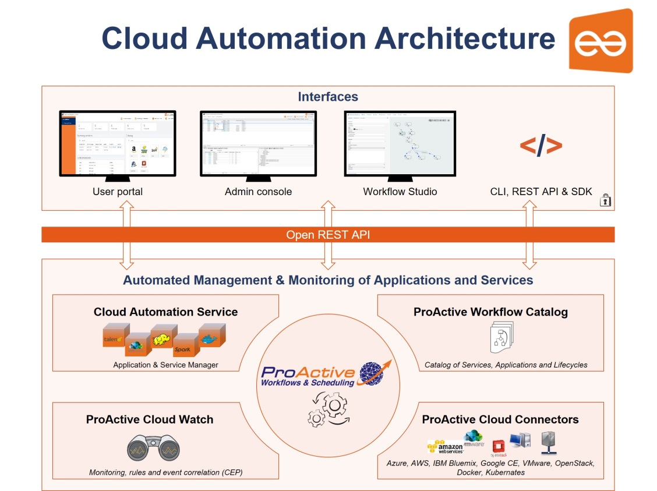

*Automation Anywhere*

* *UiPath:*

They are one of the most leading RPA vendors in the industry, already providing robotic process automation solutions to companies like SAP, EY, J.P.Morgan, Deloitte, Accenture, Capgemini, BBC etc.

*Below are 3 Robotic Process Automation products provided by UiPath,*

* *UiPath Studio*
* *Front Office and Back Office – UiPath Robots*
* *UiPath Orchestrator*

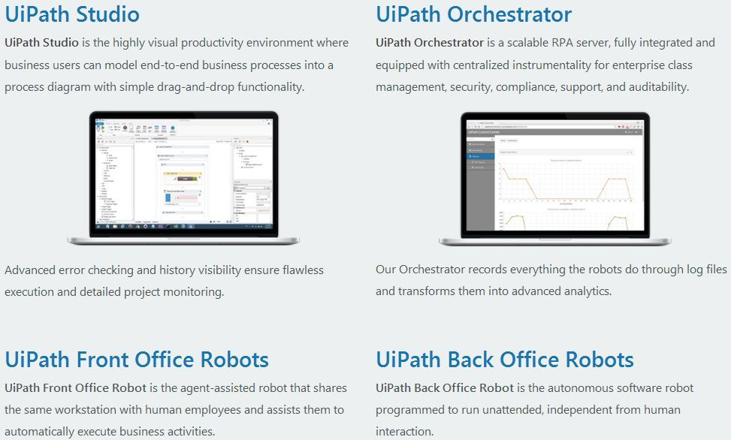

*UiPath*

***Benefits of using RPA!***

Some of the benefits of using RPA are:

* *Releases Time To Key Workers* – Performs mundane clerical tasks so key talent can focus on those activities that bring value to customers and stakeholders.
* *Stays In Tune With The Business Tempo* – Much faster to build and deploy than traditional solutions because of its codeless approach.
* *Keeps Working 24/7* – Robots can work day and night on their designated tasks.
* *Truly Agile* – Solutions can be re-trained as needed to a variety of business needs and scalable to enterprise size. In addition, solutions are ready and secure storing nothing locally.
* *Eliminates Human Errors –* Automation with RPA eliminates human errors fulfilling processes predictably every time.
* *Scalable* - Most RPA platforms are designed for enterprise scale deployment and are typically cloud based permitting truly massive scaling at very low cost.
* *Self-Serving* – Advanced solutions offer user organizations the added benefit of being able to train their own robots!
* *Easily Integrated* – Complementing rather than replacing existing systems, RPA solutions can painlessly access data from multiple, disparate sources without needing APIs or coding.

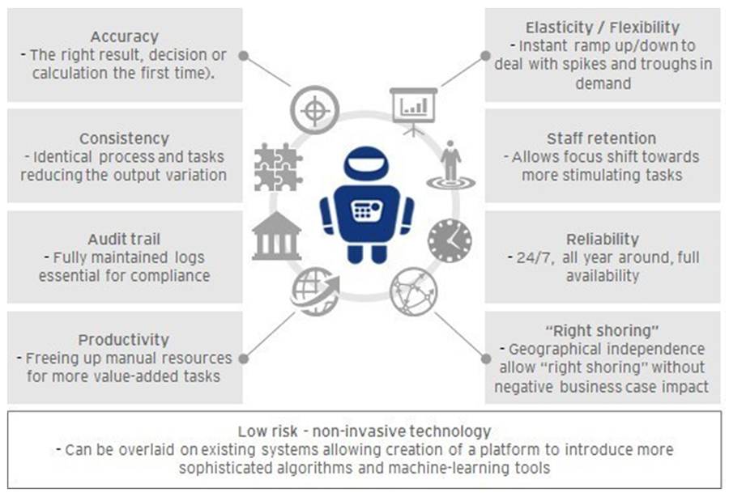

***RPA Won’t Steal Our Jobs … Can be a Great Buddy!***

As one of the many strategic initiatives that were deployed by enterprises to facilitate the optimal use of resources, RPA was introduced specifically to automate routine and standardized tasks to free up employee bandwidth so that they could focus on the core business objectives.

Bots can automate routine tasks and eliminate inefficiency, but what about higher-order work requiring judgment and perception? Developers are incorporating cognitive technologies, including machine learning and speech recognition, into robotic process automation—and giving bots new power.

So let us welcome the robots to our technical world.

